RICHARD F. HOPE

438 Independence Circle, Nazareth, PA 18064

eMail: RHope5@iCloud.com

Phone: (610) 258-7417

Cell: 908-337-9852

Website: www.2rfhope.com

8 December 2025

Dear Friend,

How’s it going this year?

As I’m approach three-quarters of a century, and Ginny approaches 80 years, we have discovered that our bodies don’t function as well as they did when we were younger. However, we continue to pursue our artistic interests.

I’m still writing: lately mostly revising my short history of mathematics; and composing piano pieces. Just now, I’ve been fulfilling a promise to my hospital staff to write a piece incorporating the sound of the alarms from the patient-room equipment.

Ginny has developed a standing with the local arts & crafts community. It’s good to see some of her projects – and now her paintings – get the recognition they deserve. It looks like she may also be teaching fused glass classes at the community college in the near future.

The children are all well and (more or less) accounted for. My youngest grandchild, Miss Violet (daughter of my fifth son), is a charming almost-2-year-old, who had dinner with us just recently, and brought her parents along for the occasion. My second son just got signed to a big pay raise, but must move from Tennessee (which he loves) to Florida (which will be more expensive). Ginny’s oldest grandchild (her first daughter’s son) is pursuing his doctoral thesis in Occupational Therapy, while her second child and family are busy travelling: to various places during vacations, and to children’s sports events during the regular year. Other children and grandchildren have spread throughout the country and, indeed, the world!
We wish you a very happy holiday season, and a grand New Year to come.
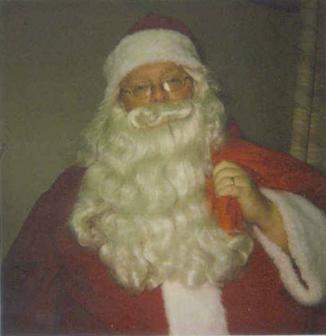
Yours,
Richard & Ginny Hope

